DTP Test Data Cleanup Procedure

# Executive Summary

This document details the procedure to clean up DTP test data found within the DTP development/test environments. It is not recommended that this procedure be run within active production environments as it will permanently destroy the data and there are currently no provisions to archive it before its destruction.

# Run the DTPTestDataCleanup.ps1 PowerShell Script

This script will delete/reset the test data within the Resource Group/Storage Account specified.

1. Deletes all DTP manifest files in the specified 'completed containers' blob container.
2. Deletes all the DTP users' containers and uploaded files listed within the transfer table.
3. Deletes all the DTP transfer records in the transfer table.
4. Removes the role assignments (see $roleDefinitionNames) specified for each user listed within the transfer table for the specified storage account (see $scope).
5. Deletes all the DTP audit records in the insights-logs-storagedelete, insights-logs-storageread, insights-logs-storagewrite containers.

## Procedure

1. Open Windows PowerShell or Windows PowerShell ISE as an Administrator.
2. Change directory to where the DTPTestDataCleanup.ps1 script is located. This can be found in the “..\Deploy\TestData\” directory.
3. Open the DTPTestDataCleanup.ps1 script:
   1. Replace the values below with your desired values.

I.E.

$resourceGroupName = "RESORCEGROUPNAME"

$storageAccountName = "STORAGEACCOUNTNAME"

$auditStorageAccountName = "AUDITSTORAGEACCOUNTNAME"

$completedContainerName = "COMPLETEDCONTAINERSNAME"

* 1. Specify the name(s) of the roledifinitions that should be removed.

I.E.

$roleDefinitionNames = @(

'DTP Storage Blob Data ReadWrite'

'Storage Blob Data Contributor'

)

* 1. Example:

$resourceGroupName = "dtp10"

$storageAccountName = "dtp10b739"

$auditStorageAccountName = "dtp10audit"

$completedContainerName = "completedcontainers"

$roleDefinitionNames = @(

'DTP Storage Blob Data ReadWrite'

'Storage Blob Data Contributor'

)

1. Run .\DTPTestDataCleanup.ps1 from the prompt or the ISE window.
2. When prompted for confirmation, select ‘y’.

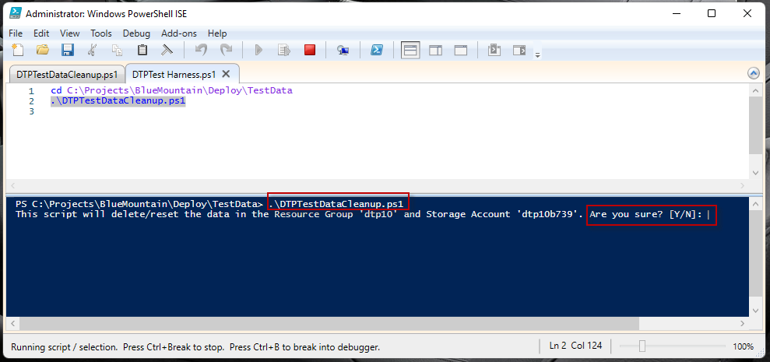

# Run the DeleteAuditsLogs.sql SQL Script

The second step is to run the DeleteAuditsLogs.sql script against the LogsListSQLDatabase database in Azure. This script will delete all records found in the Audit table.

## Procedure

1. Sign in into the Azure Subscription via the Azure portal.
2. Navigate to the log-sql-server SQL Server and select the Networking tab.
3. Ensure that your IP address has been added into the firewall rules as to allow you to connect to the LogsListSQLDatabase database.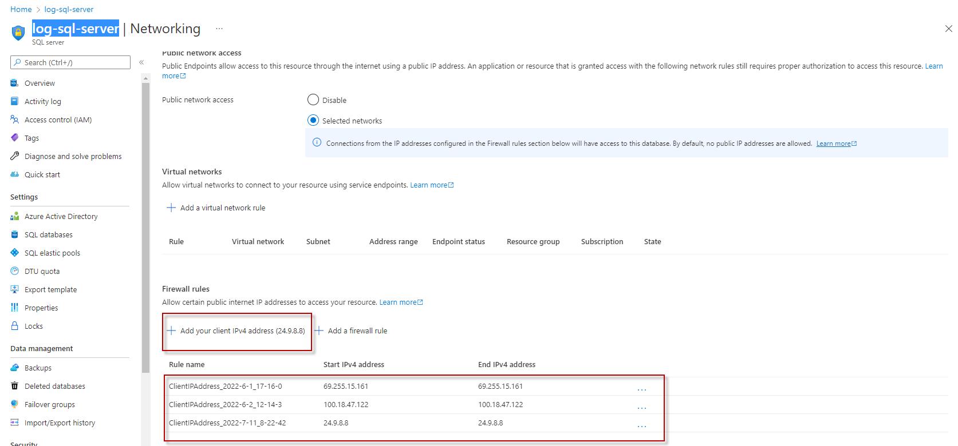
4. Open Microsoft SQL Management Studio.
5. Add a New Server Registration and connect to the log-sql-server SQL Server.

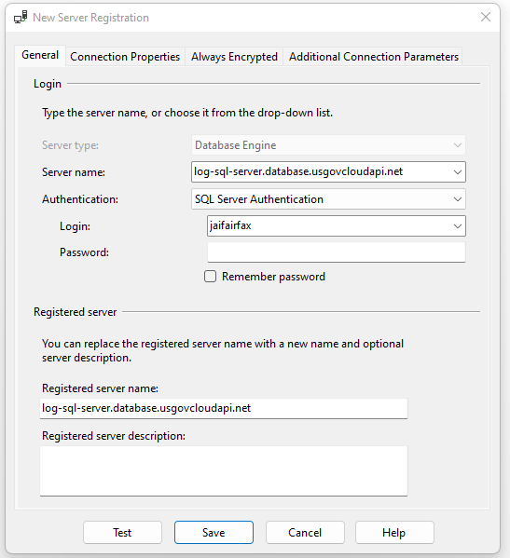

1. In a new Query window, open the DeleteAuditsLogs.sql located in the “..\Deploy\SQL” directory.
2. Execute the script.

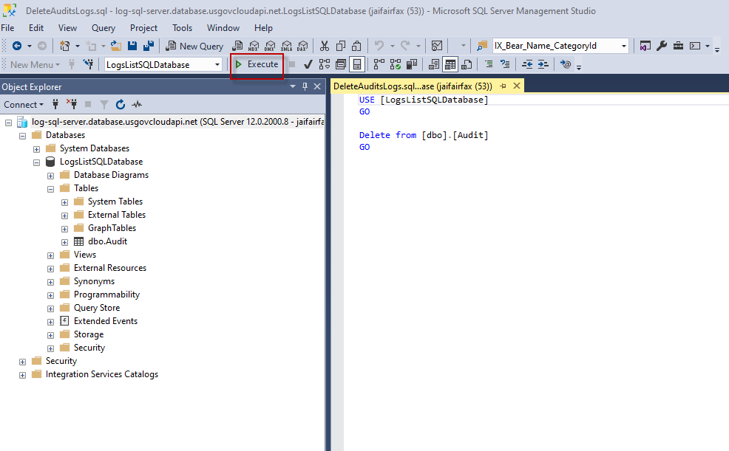

1. Alternatively, if the Azure subscription provides the Query editor within the LogsListSQLDatabase database pane, the script can also be executed within the Azure Portal.

